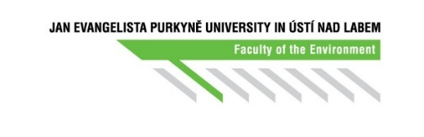

Annex 1 A

Individual study plan for study in the doctoral study programme

**Part A: Framework layout of the study for the expected period of study.[1]**

Student (name and surname, including titles):

Student's personal number:

Study programme: Landscape reclamation and ecosystem services

Student's workplace:

Supervisor:

Supervisor's workplace:

Start of study:

Planned termination:

**Dissertation topic (provisional title):**

**Planned objectives, thesis:**

**Consultant, supervisor-specialist:**

**Framework study plan of the doctoral study programme Landscape reclamation and ecosystem services:[2]**

1st year:

|  |  |  |
| --- | --- | --- |
| Name | Number of credits | Credited |
|  |  |  |
|  |  |  |
|  |  |  |
|  |  |  |
|  |  |  |
|  |  |  |

2nd year:

|  |  |  |
| --- | --- | --- |
| Name | Number of credits | Credited |
|  |  |  |
|  |  |  |
|  |  |  |
|  |  |  |
|  |  |  |
|  |  |  |
|  |  |  |

3rd year:

|  |  |  |
| --- | --- | --- |
| Name | Number of credits | Credited |
|  |  |  |
|  |  |  |
|  |  |  |
|  |  |  |
|  |  |  |

4th year:

|  |  |  |
| --- | --- | --- |
| Name | Number of credits | Credited |
|  |  |  |
|  |  |  |
|  |  |  |
|  |  |  |

**Study stays, internships at other departments, conferences:**

**Other study obligations:**

.................................................. ..................................................

student’s signature supervisor’s signature

.................................................. ..................................................

signature of chairman of DC signature of dean

**Approved by the doctoral council on:**

1. The standard period of study is 4 years.
2. The curriculum includes a detailed plan for the first year of study. Plans for further years of study are refined during annual evaluations of the course of study.