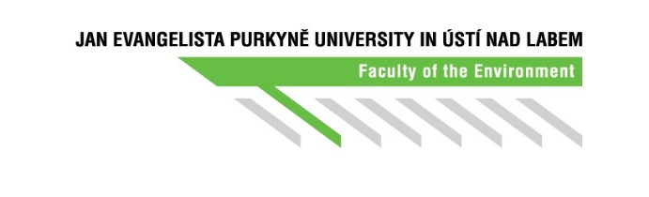

Annex No. 1A

Individual Study Plan of a Doctoral Programme

**Part A: Framework layout of the study for the expected period of education[1]**

Student (name&surname including academic degrees):

Student’s personal number:

Study programme: *Environmental and Biomaterial Sciences*

Workplace of student:

Supervisor:

Workplace of supervisor:

Start of the study:

The expected end of the study:

**Topic(s) and thesis of dissertation (working title):**

**Planned goals, main ideas of the dissertation:**

**Consultant, Supervisor-specialist:**

**Framework layout of the study programme *Environmental and Biomaterials Sciences*:[2]**

1st year:

|  |  |  |  |
| --- | --- | --- | --- |
| Abbreviation | Title | Credits | Lecturer |
|  |  |  |  |
|  |  |  |  |
|  |  |  |  |
|  |  |  |  |
|  |  |  |  |
|  |  |  |  |
|  |  |  |  |

2nd year:

|  |  |  |  |
| --- | --- | --- | --- |
| Abbreviation | Title | Credits | Lecturer |
|  |  |  |  |
|  |  |  |  |
|  |  |  |  |
|  |  |  |  |
|  |  |  |  |
|  |  |  |  |
|  |  |  |  |
|  |  |  |  |

3rd year:

|  |  |  |  |
| --- | --- | --- | --- |
| Abbreviation | Title | Credits | Lecturer |
|  |  |  |  |
|  |  |  |  |
|  |  |  |  |
|  |  |  |  |
|  |  |  |  |
|  |  |  |  |

4th year:

|  |  |  |  |
| --- | --- | --- | --- |
| Abbreviation | Title | Credits | Lecturer |
|  |  |  |  |
|  |  |  |  |
|  |  |  |  |
|  |  |  |  |

**Internships, trainings at other workplaces, conferences:**

**Other study obligations:**

.................................................. ..................................................

Student's signature Supervisor's signature

.................................................. ..................................................

Signature of the chair of the doctoral council Dean´s signature

**Approved by the doctoral council on:**

1. Standard period of study is 4 years.
2. Please include a detailed plan for the first year of study. Details of the following years of study will be specified in the study course's annual evaluation document.